**Lab Report**

Title: Finding Dory’s Optimal Path

Notice: Dr. Bryan Runck

Author: Lauren Roach

Date: November 2, 2022

**Project Repository:** https://github.com/L-roach/GIS5571/tree/main/Lab2

**Google Drive Link:** N/A

**Time Spent:** 40 hours

**Abstract**

Dory lives at a farm site and wants to find the best walking path to reach her favorite fly-fishing location. By using elevation data, land cover information, and the locations of various streams and waterways in the area, a cost surface analysis is created in this part of the lab to objectively find that optimal walking path according to Dory’s criteria.

**Problem Statement**

Creating an optimal walking path for Dory first requires understanding her specifications. Since Dory does not like to walk on farm fields, cross bodies of water unless she is wearing her waders, and prefers the most gradual slope, these preferences will inform the type of rasters created to complete the cost surface analysis—and thus determine the data required.

Table 1. Data needed for Cost Surface Analysis

|  |  |  |  |  |  |  |
| --- | --- | --- | --- | --- | --- | --- |
| **#** | **Requirement** | **Defined As** | **(Spatial) Data** | **Attribute Data** | **Dataset** | **Preparation** |
| 1 | Elevation data | Points indicating elevation | DEM file | Point | [Mn GeoSpatial Commons](https://gisdata.mn.gov/dataset/trans-roads-mndot-tis) | Convert to raster and clip |
| 2 | Land Cover information | Land classification file | TIF file | Classification | MN Geospatial Commons | Convert to raster and clip |
| 3 | Stream routes | Polyline shapefile that contains major stream centerlines | Shapefile | Line | MN Geospatial Commons | Convert to raster and clip |
| 4 | Dory’s Locations | Location data as points | XY points | None | CSV | Display XY data |

**Input Data**

To understand the slope for the cost surface analysis, elevation data are needed to calculate the percent slope across the land of interest. The land cover classification data are needed to understand where the farm parcels are in the area of interest. The stream centerlines are needed to calculate where the water bodies are to avoid when Dory is not wearing waders. Dory’s locations are needed to understand where the start and end points are in the area of interest to ultimately calculate the optimal path.

Table 2. Data Used

|  |  |  |  |
| --- | --- | --- | --- |
| **#** | **Title** | **Purpose in Analysis** | **Link to Source** |
| 1 | Elevation 30 meter resolution | Used to calculate the slope for the surfaces | [Mn GeoSpatial Commons](https://gisdata.mn.gov/dataset/trans-roads-mndot-tis) |
| 2 | Land cover classification | Used to understand land in the area of interest; this was reclassified to give farm parcels lower suitability and other areas higher suitability | MN Geospatial Commons |
| 3 | Stream Routes and Centerlines | Shapefile used to delineate water bodies in the area | MN Geospatial Commons |
| 4 | Dory’s locations | Coordinates used in XY table to point | Lab 2 Details |

**Methods**

To create the optimal path, first data was extracted from the MN Geospatial Commons using the requests and zipfile packages in Jupyter Notebooks. Also, the coordinates of Dory’s start and end points were added as a csv file and then the XY table to point tool was used to locate these points on the map. Then, a box was created around these points to define the area of interest and analysis. The elevation data, land cover data, and stream shapefile were all clipped to this area of interest.

Then, a slope raster was calculated using the elevation data, and “percent rise” was used as the slope value. The land cover data was reclassified so that the farm fields were given high values, as undesirable for the walking path, and the scale was 0 to 10 for all the land cover. The streams shapefile was converted to a raster. These reclassifications and calculations are shown in the following figures.

The flow direction tool was used to create a new raster from the slope raster, for input in the optimal path as a raster tool. The weighted sum tool was used to combine the slope and reclassified land cover raster layers indicating Dory’s preferences. The first time, this was calculated with a weight of 0.7 for the slope raster and 0.3 for the land cover raster, thinking that some days Dory wore her waders and was more willing to travel near water. Another weighted sum raster was created with a 0.6 weight for land cover and 0.4 weight for slope to reflect that Dory may one day really want to avoid water and be more willing to travel across greater slopes. The walking path was calculated using the optimal region connections first. Then, to check the path that was created, the optimal path as a raster tool was used. This tool was used twice, once with the first weighted sum raster and another time with the other weighted sum raster, depicted below.

Figure 1. Data flow diagram for finding Dory’s path

Figure 2. Original Land cover clip

Figure 3. Reclassified Land cover clip

Figure 4. Slope raster calculated from elevation DEM

Figure 5. Flow direction raster (for input in the optimal path tool)

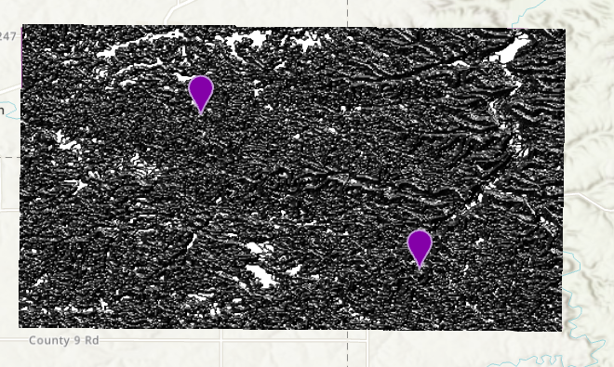

**Results**

According to the results, Dory has two optimal walking paths to travel from her farm site to her favorite fly fishing spot. The two routes differ so that when she is wearing her waders, she can follow the blue path, and when she is not wearing any waders and is willing to travel a greater slope, she can follow the teal path. Both paths are shown in the following figures.

Figure 6. First optimal path created

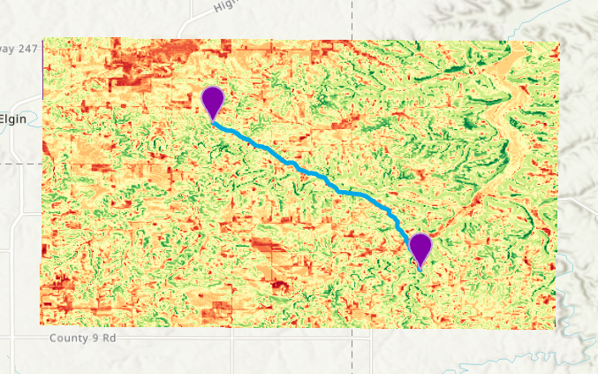

Figure 7. Second optimal walking path created with the second weighted sum raster

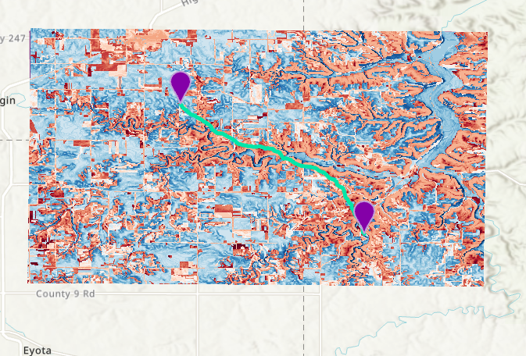

Figure 8. Map with both routes displayed

**Results Verification**

Because there were multiple optimal path tools to use within the arcpy toolbox, I used three different tools to verify the paths created. The optimal path as a line tool created the same path as the optimal region connections tool. These tools created a similar path to the first weighted sum cost surface calculation. Thus, three tools created the same path which serves as a results verification.

**Discussion and Conclusion**

Initially, I struggled to create the weighted sum calculation, but soon I realized that I did not reclassify my input raster layers to reflect the same scale. Once I did this, the weighted sum raster tool worked. Also, I struggled to find the right optimal path tool since there were multiple choices and at first, I could not get the optimal path as a line tool to work. Once I troubleshooted and consulted my resources, I was able to use all three tools and compare the paths created.

Overall, using multiple raster layers is an efficient and effective way of finding an optimal path between two locations on a map. The calculations completed here created two options for a walking path for Dory. Dory will now have routes for when she is wearing her waiters and when she is not.

**References**

None to report.

**Self-score**

|  |  |  |  |
| --- | --- | --- | --- |
| **Category** | **Description** | **Points Possible** | **Score** |
| **Structural Elements** | All elements of a lab report are included **(2 points each)**:  Title, Notice: Dr. Bryan Runck, Author, Project Repository, Date, Abstract, Problem Statement, Input Data w/ tables, Methods w/ Data, Flow Diagrams, Results, Results Verification, Discussion and Conclusion, References in common format, Self-score | 28 | **28** |
| **Clarity of Content** | Each element above is executed at a professional level so that someone can understand the goal, data, methods, results, and their validity and implications in a 5 minute reading at a cursory-level, and in a 30 minute meeting at a deep level **(12 points)**. There is a clear connection from data to results to discussion and conclusion **(12 points)**. | 24 | **22** |
| **Reproducibility** | Results are completely reproducible by someone with basic GIS training. There is no ambiguity in data flow or rationale for data operations. Every step is documented and justified. | 28 | **26** |
| **Verification** | Results are correct in that they have been verified in comparison to some standard. The standard is clearly stated **(10 points)**, the method of comparison is clearly stated **(5 points)**, and the result of verification is clearly stated **(5 points)**. | 20 | **20** |
|  |  | 100 | **96** |